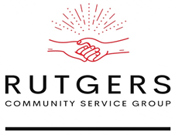Cian Maillard

Communications/ Task Manager

Rutgers Community Service Group

203 Wissahickon Trail

Browns Mills NJ, 08015

Clients Name

Title

Address 1

Address 2

Dear [Clients Name],

My name is Cian Maillard and I am the communication manager of a student project team called Rutgers Community Service Group. The Rutgers Community Service team consists of our principal writers, Mark Chen and Himesh Buch, our progress reporter, Zuzanna Wlodarska, and myself. We are currently taking a technical writing essentials course at Rutgers University of New Jersey and our professor, Dave Howland, has assigned a project that requests we utilize our technical writing skills to help a non-profit client. I am writing you today to inquire whether the Rutgers Community Service Group could help your organization with your technical writing needs.

Our project is scheduled to last eight weeks and is designed to help us apply the skills we have learned at Rutgers University to a professional and real world environment. If you were to work with us, our team would develop several written documents. In past semesters, groups have created websites, pamphlets, and even logos. To ensure open dialogue and a productive experience, we would require you to meet with us weekly for the duration of the project.  These meetings would allow us to discuss design choices and receive your feedback at each stage of development. The project will be completed by December 1st and will be presented in class on either December 2nd or December 3rd. If you choose to work with us, we highly encourage you to attend our in-class presentation. After the final presentation, all our completed work will be yours and you are free to use it as your organization sees fit.

Please do contact me with any questions and concerns. We look forward to hearing from you and scheduling a meeting. I can be reached at 609-997-1375 or [cem287@scarletmail.rutgers.edu](mailto:cem287@scarletmail.rutgers.edu)  Thank you for your time.

Sincerely,

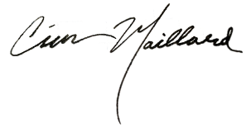

Cian Maillard